BCI data classification 2003 - Graz data set

Akash Narayana, Mohan Sadashivaiah, Raveendran Rengaswamy, Shanmukh Katragadda
FirstName.secondName@daimlerchrysler.com
DaimlerChrysler Research & Technology India Pvt Ltd., 137 Infantry road,
Bangalore-560001, India

The following feature extraction method was employed for classification of the BCI data set. Training was performed using (training) data between time points from 4s to 6s. A negative classifier output corresponds to class 1, a positive output to class 2, and zero for reject class.

Spectral Ratio of channel 1 and 3

In this method, only channels #1(C3) and #3 (C4) were used. Channel #2 was not showing any correlation with the classes, so it was not considered for classification.

The AR spectrum for each window of 128 samples with a window shift of one sample was computed. The spectra were computed for both channels 1 and 3. The spectrum was divided into four frequency bands and the energy in each band was computed for both the channels. The resulting band energies from channel 3 were divided by the energy of the corresponding frequency band of channel 1.

This results in a four dimensional feature vector. These features were fed to a Linear Discriminant Analyser (LDA), which uses Mahalanobis distance measure for classification. This results in the classification of the signal at every sample after an initial delay of 128 samples (=1s).

Results:
The mutual information plot on the training data set is as shown in Fig1.
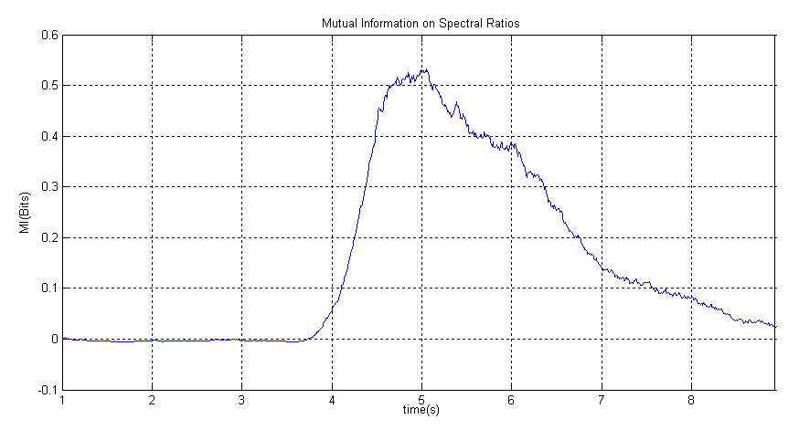
Fig1: Mutual information on the training set.

The classifier outputs (called Dt’s here) are attached separately.

DC_SR_TrainingSetDtClass1.txt: Dt’s of class1 - training set.
DC_SR_TrainingSetDtClass2.txt: Dt’s of class2 - training set.
DC_SR_TestSetDt.txt: Dt’s on the test dataset.

