BCI data classification 2003 - Graz data set

Mohan Sadashivaiah ,Akash Narayana, Raveendran Rengaswamy, Shanmukh Katragadda
FirstName.secondName@daimlerchrysler.com
DaimlerChrysler Research & Technology India Pvt Ltd., 137 Infantry road,
Bangalore-560001, India

The following feature extraction method was employed for classification of the BCI data set. Training was performed using (training) data between time points from 4s to 6s. A negative classifier output corresponds to class 1, a positive output to class 2, and zero for reject class.

AR coefficients for channels 1 and 3

In this method, channels #1 and #3 were used. AR coefficients of order 6 were extracted from both the channels. The AR coefficients were computed for a window of 128 samples with a shift of 1 sample.

This results in 12 dimensional feature vector ( 6 AR coefficients from each of the two channels). These features were fed to a LDA, which uses Mahalanobis distance measure for classification. This also results in the classification of the signal at every sample after an initial delay of 128 samples (=1s).

Results:
The mutual information plot on the training data set is as shown in Fig1.
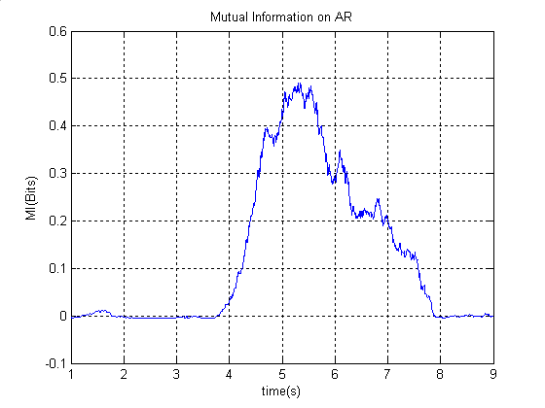
Fig1: Mutual information on the training set .

The classifier outputs are attached separately.
DC_AR_TrainingSetDtClass1.txt: Dt’s of class1 - training set.
DC_AR_TrainingSetDtClass2.txt: Dt’s of class2 - training set.
DC_AR_TestSetDt.txt: Dt’s on the test dataset.

