Data set IV: self-paced 1s
Group Information:
Department of Biomedical Engineering,
Tsinghua University
Beijing, 100084, P. R. China
Supervisor: Zhiguang Zhang . (zzg@tsinghua.edu.cn)
Team Member: Yijun Wang,
Yong Li,
Xiaorong Gao
Counselor: Shangkai GAO, Fusheng YANG

Estimated labels: (listed also in TSINGHUA_y_test.mat)
0 0 0 0 1 0 0 0 1 1 (10)
1 0 0 1 1 0 0 1 0 0 (20)
0 0 0 1 0 1 1 1 0 1 (30)
0 0 0 1 0 0 1 0 1 0 (40)
1 1 0 0 0 1 0 0 0 1 (50)
1 1 1 0 0 1 1 1 0 1 (60)
1 0 0 1 0 0 0 1 0 1 (70)
0 1 1 0 0 0 0 1 0 1 (80)
0 1 1 0 1 1 0 0 1 1 (90)
0 0 1 0 1 1 0 1 1 0 (100)
Processing technique:
Combine CSSD (Common spatial subspace decomposition) and FD (Fisher discrimination) to extract 3 features (f_{i}=w_{i}^{T}x_{i+}b_{i}, i=1,2,3) from the single trial EEG, and then use a simple perceptron neural network to classify (select 48 samples near the discriminating plane for training).

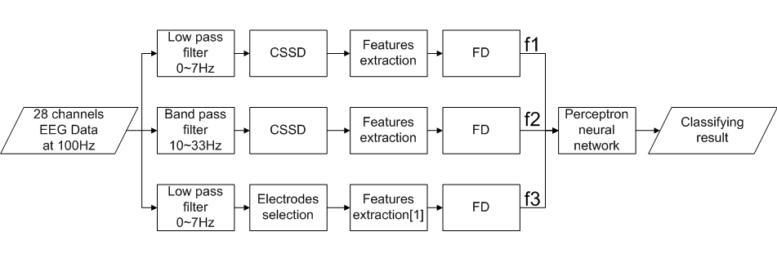

Reference:
[1]Benjamin Blankertz, Gabriel Curio and Klaus-Robert Müller, “Classifying Single Trial EEG: Towards Brain Computer Interfacing,” T. G. Diettrich and S. Becker and Z. Ghahramani. Advances in Neural Information Processing Systems (NIPS 01). New York, MIT Press. 2002.

